This press release has been updated to correct the attribution of the quote from the KAMA representative. The Media Contacts have been updated as well.

FOR IMMEDIATE RELEASE

IMPACK Collaborates with KAMA to Offer Seemless Solution for Folding Carton Finishing Lines

Saint Jacques, Quebec, Canada, September 9, 2024 – IMPACK, a leading innovator in folder-gluer peripherals, is proud to announce its collaboration with KAMA, a global leader in finishing die-cutters and folding-gluing machines. Together, the two companies are delivering a powerful, cost-effective solution that meets the needs of modern packaging producers.

Complementary Technologies

At the heart of this collaboration is the seamless pairing of IMPACK's ERGOSA Semi-Automatic Packer with KAMA's FlexFold 52i folder-gluer. Designed specifically for short-run production, the FlexFold 52i offers fully automatic adjustments, allowing for over 100 order changeovers in a single day. Designed for fast changeovers and adaptability, the ERGOSA helps packaging producers maximize the real-life speed potential of KAMA's high-performance FlexFold 52i.

IMPACK Deputy General Manager Mathieu Tremblay explains: “IMPACK's ERGOSA Semi-Automatic Packer is the perfect complementary solution to KAMA's FlexFold 52i, offering a seemless solution for packaging producers looking to maximize efficiency on the finishing line. This partnership underscores the dedication of both IMPACK and KAMA to providing cutting-edge, reliable solutions for their customers.”

IMPACK and KAMA engineers worked together to define the best ERGOSA configurations for the FlexFold 52i. Kama has the rights to sell those specific configurations directly with their folder-gluers. For more diverse needs and special cases clients can discuss other solutions in IMPACK’s machine portfolio with our sales and engineering team.

KAMA’s reputation, built over 100 years of excellence in precision manufacturing, combined with IMPACK's expertise in folder-gluer peripherals, creates a shared DNA of design innovation and expert knowledge. Both companies are committed to serving the needs of packaging producers' finishing lines and are focused on driving productivity, efficiency, and customer satisfaction.

“We are very pleased about the promising cooperation with the Canadian manufacturer IMPACK”, says KAMA Head of Sales Europe Stefan Kleditzch. “With IMPACK, we have found the ideal partner for packing the finished folding cartons from our automatic folder gluer FlexFold 52i. Both companies share a common vision: the highest quality and precision in machine manufacturing. This partnership allows us to combine our strengths and offer a seamless, efficient complete solution. The fully automatic FlexFold 52i and the subsequent packaging system Ergosa perfectly harmonize in terms of speed and formats. Together, we offer packaging manufacturers and brand owners a sophisticated overall solution for folding carton production that supports the machine operator and significantly increases productivity.”

IMPACK Area Sales Manager for German speaking countries, Natascha Döme said, “This project is a strong example of how we, as industry-focused machine builders, work together on solutions that create real added value for our customers. I'm looking forward to working together to address a real need in packaging production facilities.”

IMAGES:

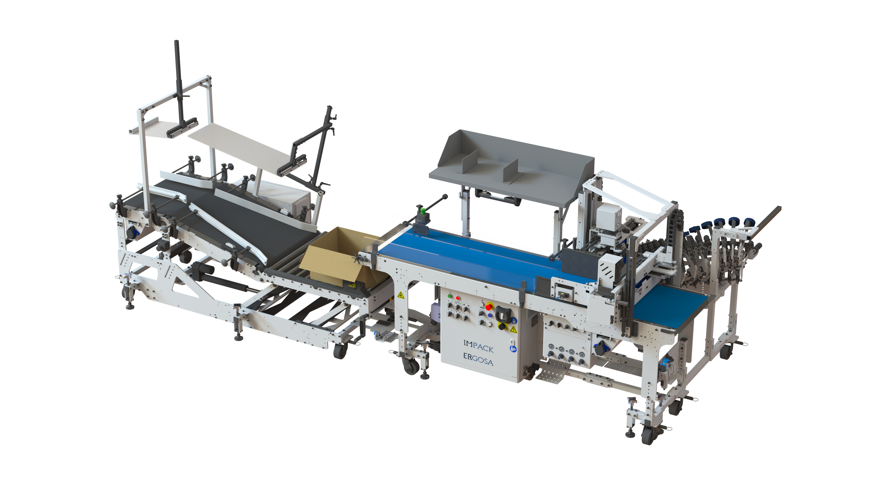The ERGOSA is available inline or with a right angle configuration.

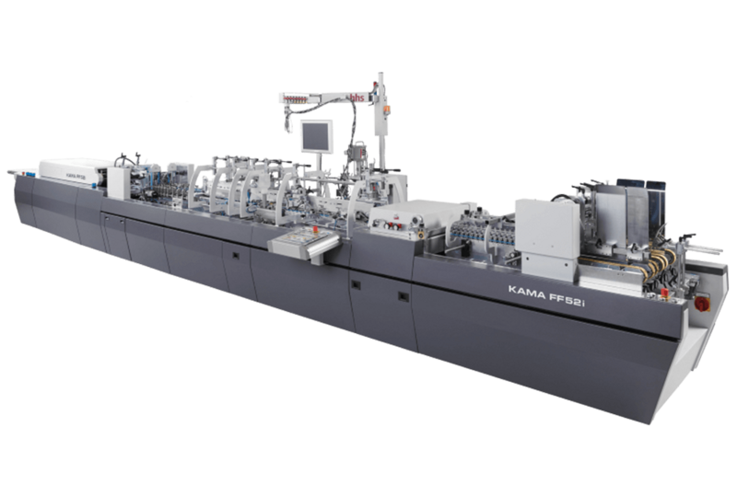KAMA's FlexFold 52i is optimized for short runs and fast changeovers.

KAMA and IMPACK recently showcased the optimized solution at FACHPACK 2024.

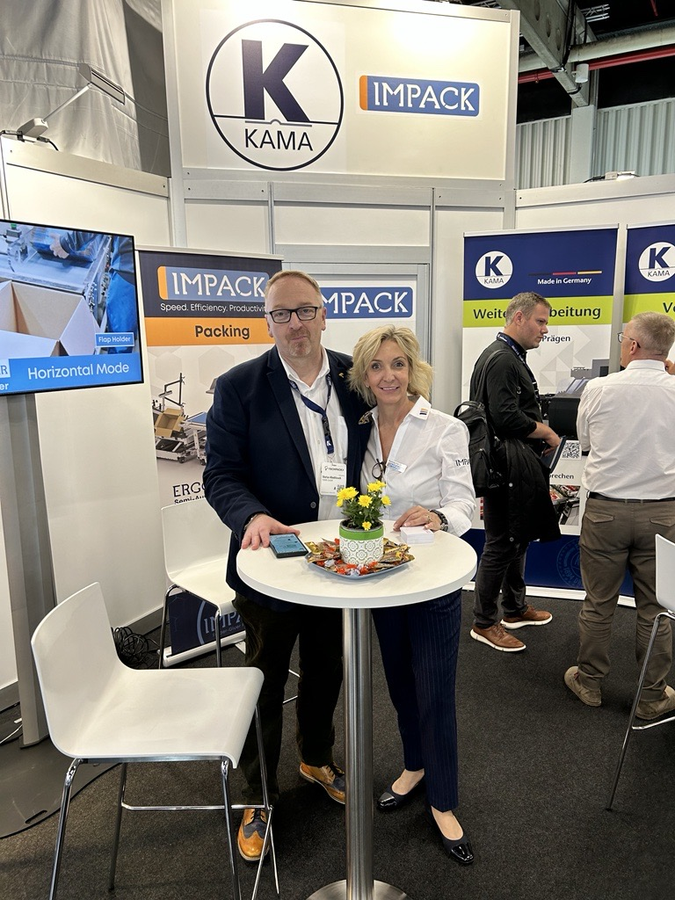

Pictured: Stefan Kleditzsch, KAMA Head of Sales Central Europe with Natascha Döme, IMPACK Area Sales Manager – D-A-CH

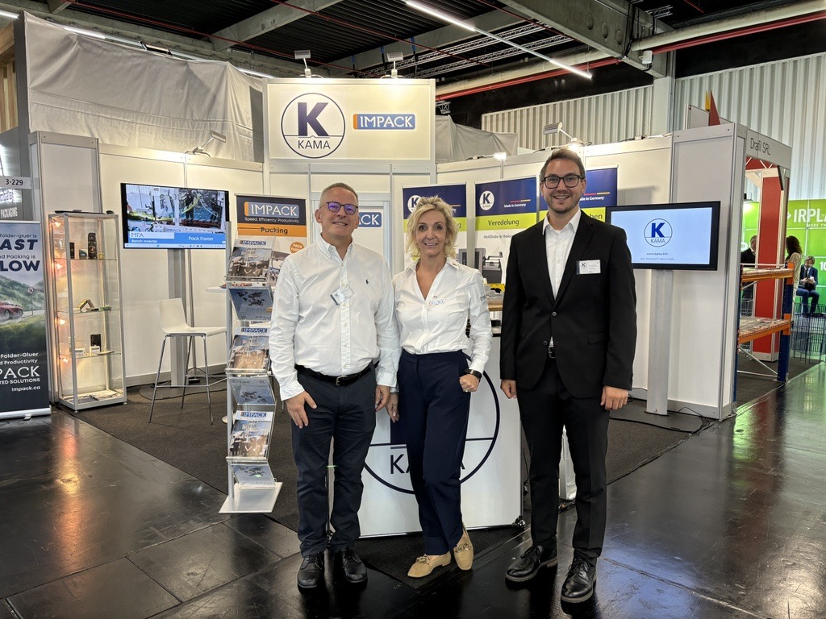

Pictured Left to Right: Thomas Kunst, KAMA Sales Manager - Central Europe, Natascha Döme, IMPACK Area Sales Manager – D-A-CH, Matthias Miederer, KAMA Head of Product Management

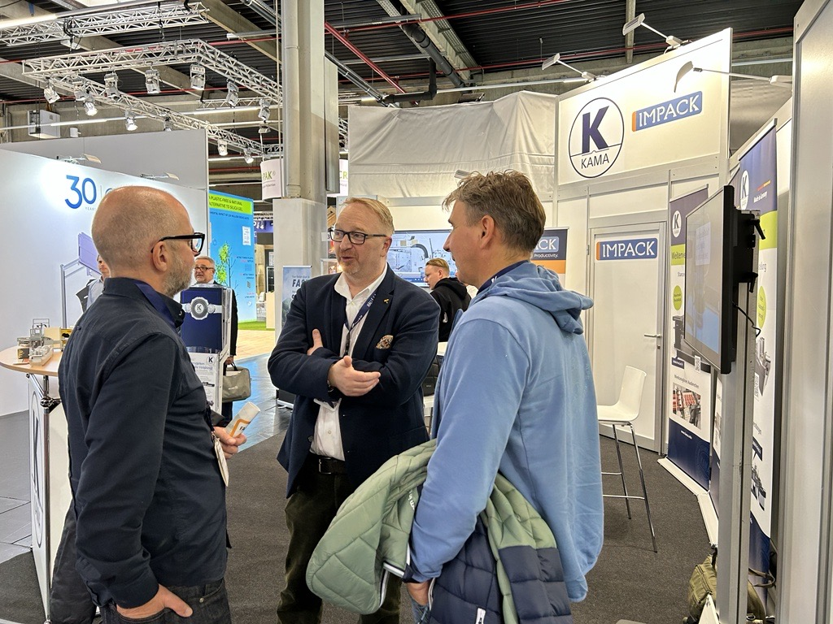

Pictured: Stefan Kleditzsch, KAMA Head of Sales Central Europe with FACHPACK 2024 attendees

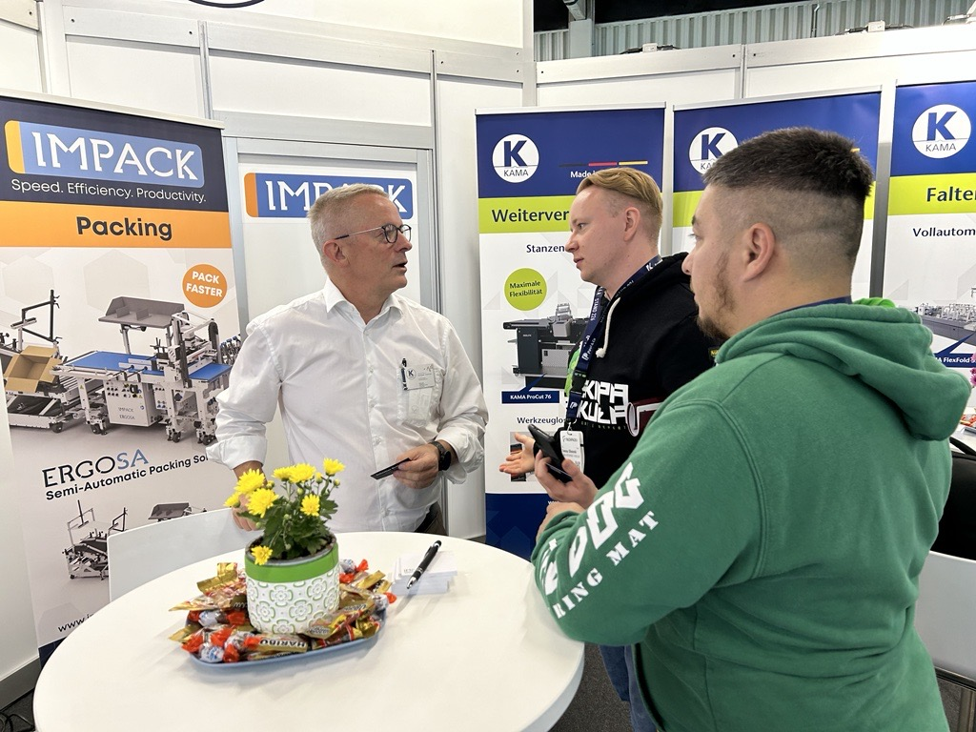

Pictured: Thomas Kunst, KAMA Sales Manager - Central Europe with FACHPACK 2024

About IMPACK

IMPACK is an engineering company that designs and manufactures folder-gluer peripherals for folding carton and corrugated box packaging producers. Our comprehensive product range includes in-line window patchers, pre-feeders, box turners, packers, stackers, batch inverters, as well as counting and separating modules. Our collaborative approach ensures that our clients get tailored solutions that eliminate bottlenecks and optimize workflows.

With over 20 years of experience analyzing packaging production workflows and methods, our machines are meticulously engineered based on insights gained from thousands of client interactions. We design solutions that help operators and packers to work more ergonomically and efficiently so that they can increase folder-gluer speed and ultimately production capacity.

About KAMA

For over 130 years, KAMA has been engineering success in the packaging, commercial printing, and finishing industries. As a trusted premium manufacturer, KAMA’s high-quality finishing die-cutters, embellishment and folding-gluing machines are renowned for their precision and reliability around the globe. KAMA offers a wide range of profitable solutions tailored to the needs of small and medium-sized print runs, making them an essential partner for the commercial print and packaging markets. Their cutting-edge technology serves a broad clientele, from job printers and finishing companies to major players in the packaging and printing sectors.

About IMPACK(short)

IMPACK designs and manufactures peripherals for folder-gluers, providing innovative solutions that increase productivity and efficiency for packaging producers worldwide.

About KAMA(Short)

KAMA is a global leader in high-quality finishing die-cutters and folding-gluing machines, offering innovative solutions for the cost-effective production of digitally printed cartons and packaging.

For media inquiries, please contact:

Fawn Alleyne

Marketing Manager

IMPACK

1 450 839 7272

[fawna@impack.ca](mailto:fawna@impack.ca)

[www.impack.ca](http://www.impack.ca/)

KAMA Media Contact:

Ruth Isheim

Head of Communications

[isheim@kama.info](mailto:media@impack.ca)

[www.kama.info](http://www.kama.info/)