IMPACK Begins Construction on New Machine Assembly Facility to Meet Growing Demand
SAINT-JACQUES, Quebec – June 22, 2026
IMPACK has officially begun construction on a new machine assembly facility. Located adjacent to IMPACK’s current headquarters, the new facility is designed to support increasing production needs while enhancing the efficiency of operations.

The new building will feature:
- Six new assembly workstations to increase our manufacturing capacity
- A dedicated shipping dock to streamline logistics and product distribution
- Modern office space for IMPACK's growing team
- A centralized parts storage area to improve inventory management and workflow

Once completed, this expansion will allow IMPACK to reorganize the current building which will be primarily dedicated to engineering and new product development. This re-organization will create a more efficient workflow across all departments while providing the capacity needed to support future growth.
Construction officially began on June 22, 2026. IMPACK will share project updates as work progresses.

Media Contact:
Fawn Alleyne
Director of Marketing
+1 450-839-7272
marketing@impack.ca

ABOUT IMPACK
For 25 years, IMPACK has specialized in designing and manufacturing innovative automation solutions for folder-gluer end-of-line operations in the folding carton and corrugated packaging industries. By studying production lines and understanding manufacturers' operational challenges, the company's engineers develop solutions that eliminate bottlenecks, improve ergonomics, and increase productivity.

Photo options, captions & download links:
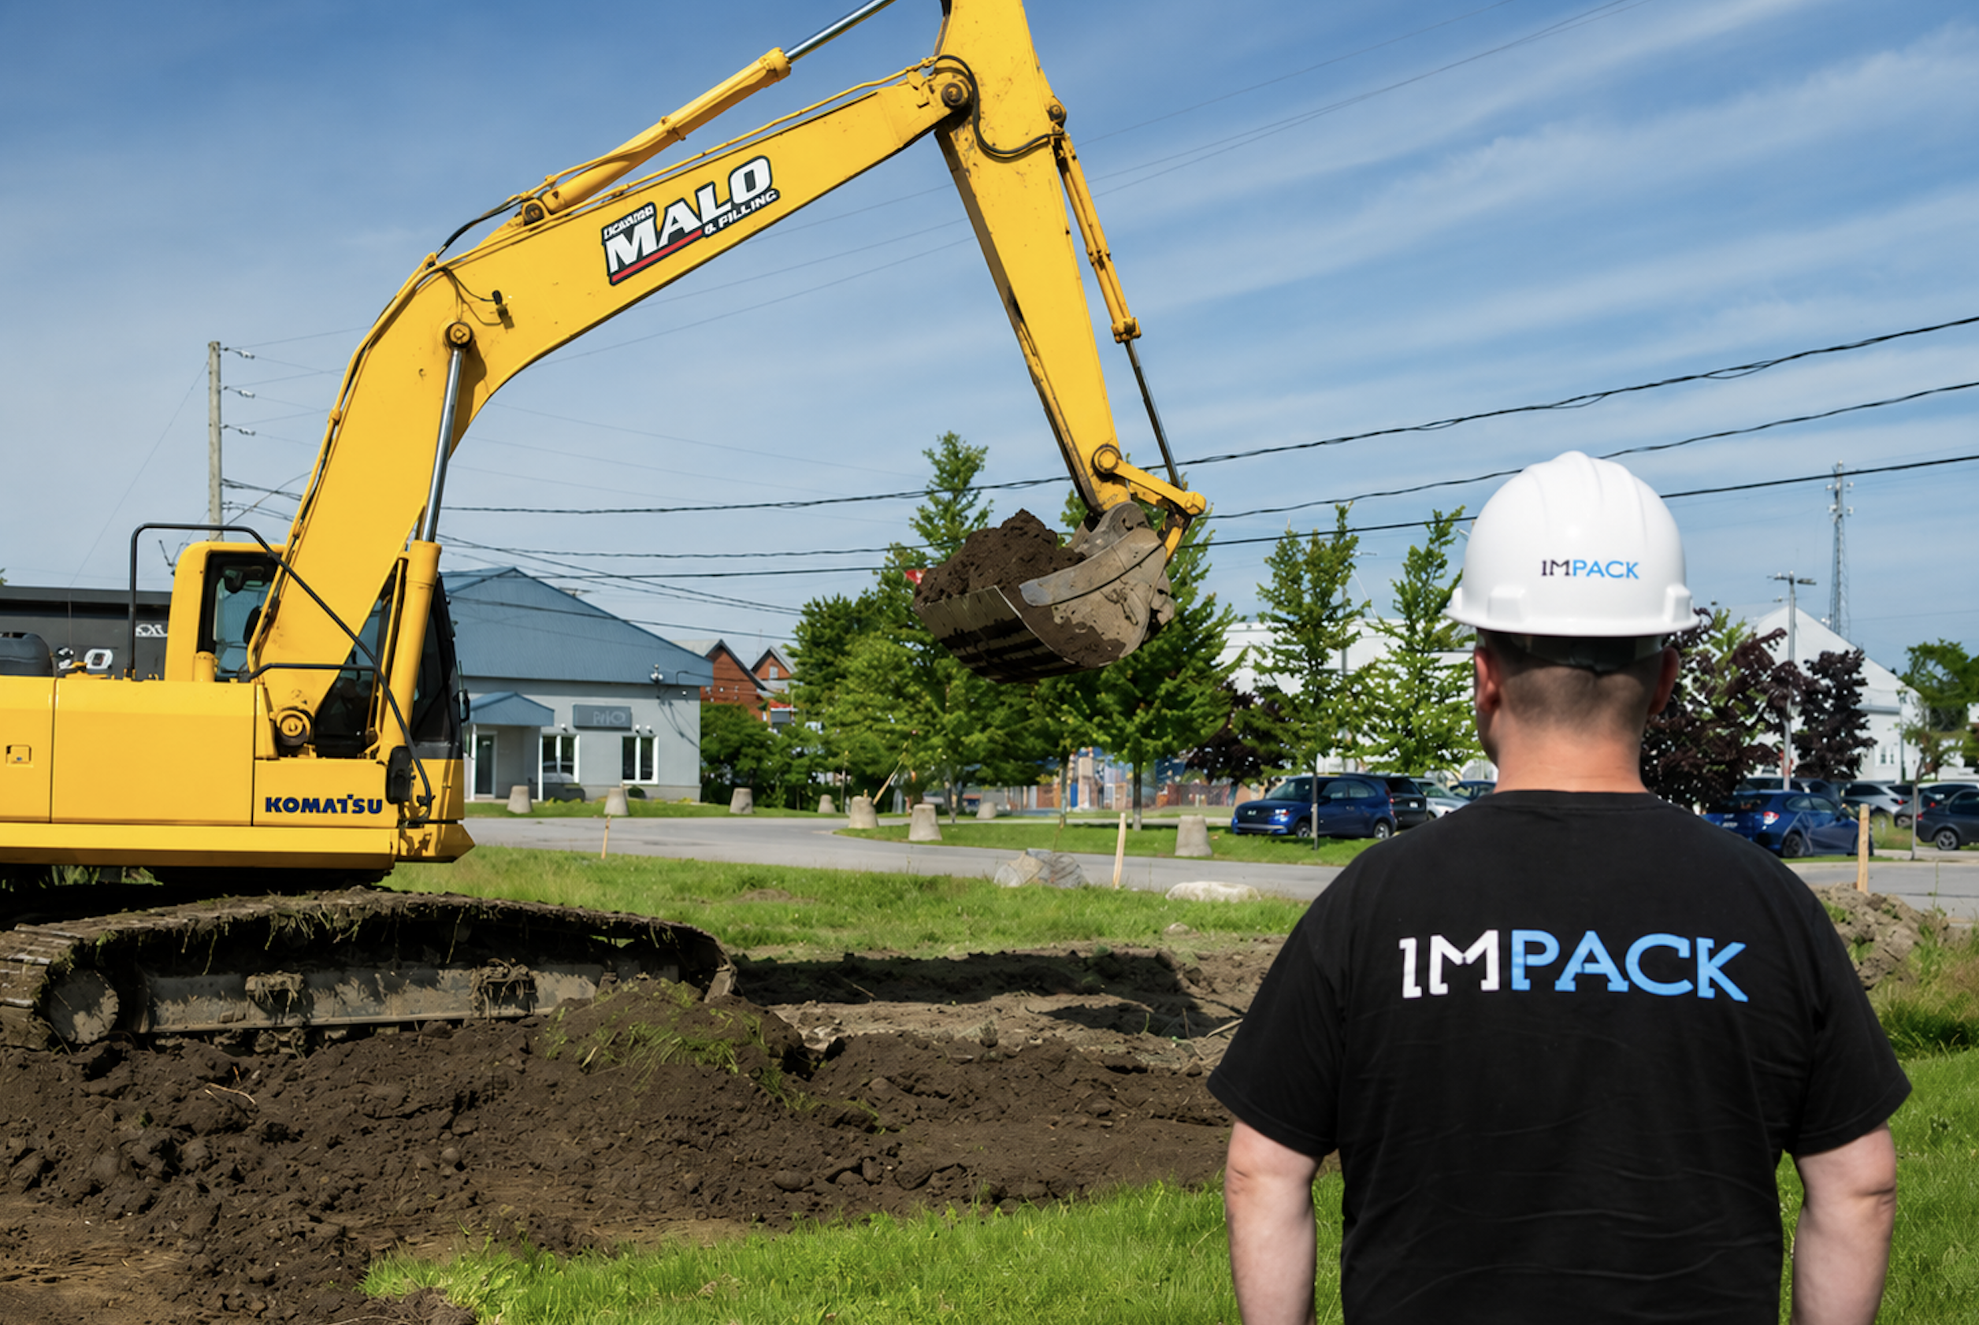

Excavation work kicks off an important milestone in IMPACK history.
https://mktg.impack.ca/hubfs/2026%20Media%20Kits%20Press%20Releases/2026-06%20impack%20groundbreaking/2026-07-impack-new-building-groundbreaking-FXA06860.png

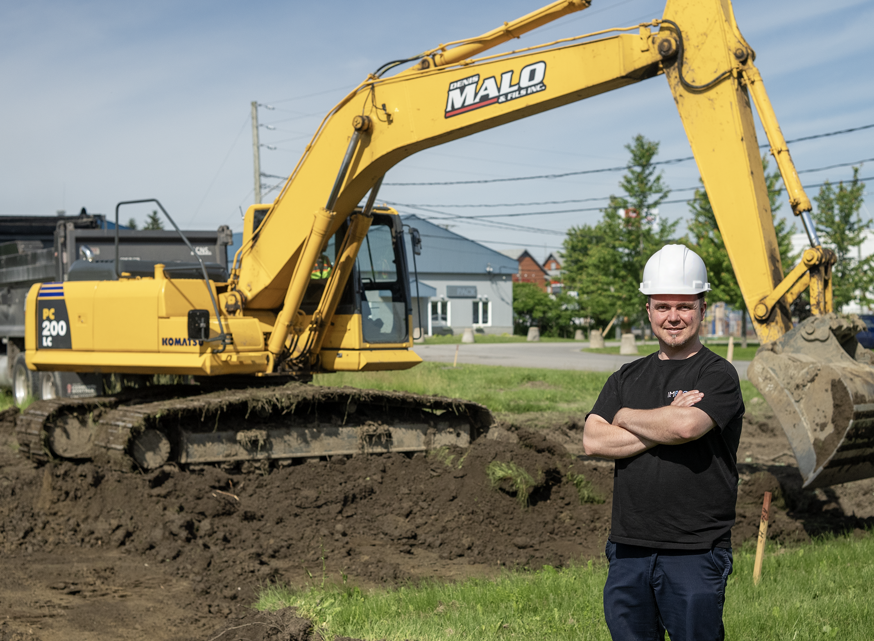
IMPACK Plant Director Michael Persechino's efforts played a key role in bringing this expansion project to life.
https://mktg.impack.ca/hubfs/2026%20Media%20Kits%20Press%20Releases/2026-06%20impack%20groundbreaking/2026-07-impack-new-building-groundbreaking-FXA06922.png

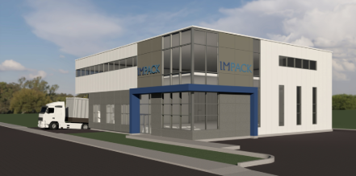

3D architectural rendering of IMPACK's future machine assembly facility, designed to support continued growth, innovation, and manufacturing capacity.
https://mktg.impack.ca/hubfs/2026%20Media%20Kits%20Press%20Releases/2026-06%20impack%20groundbreaking/2026-impack-new-building-3D-render-02.png
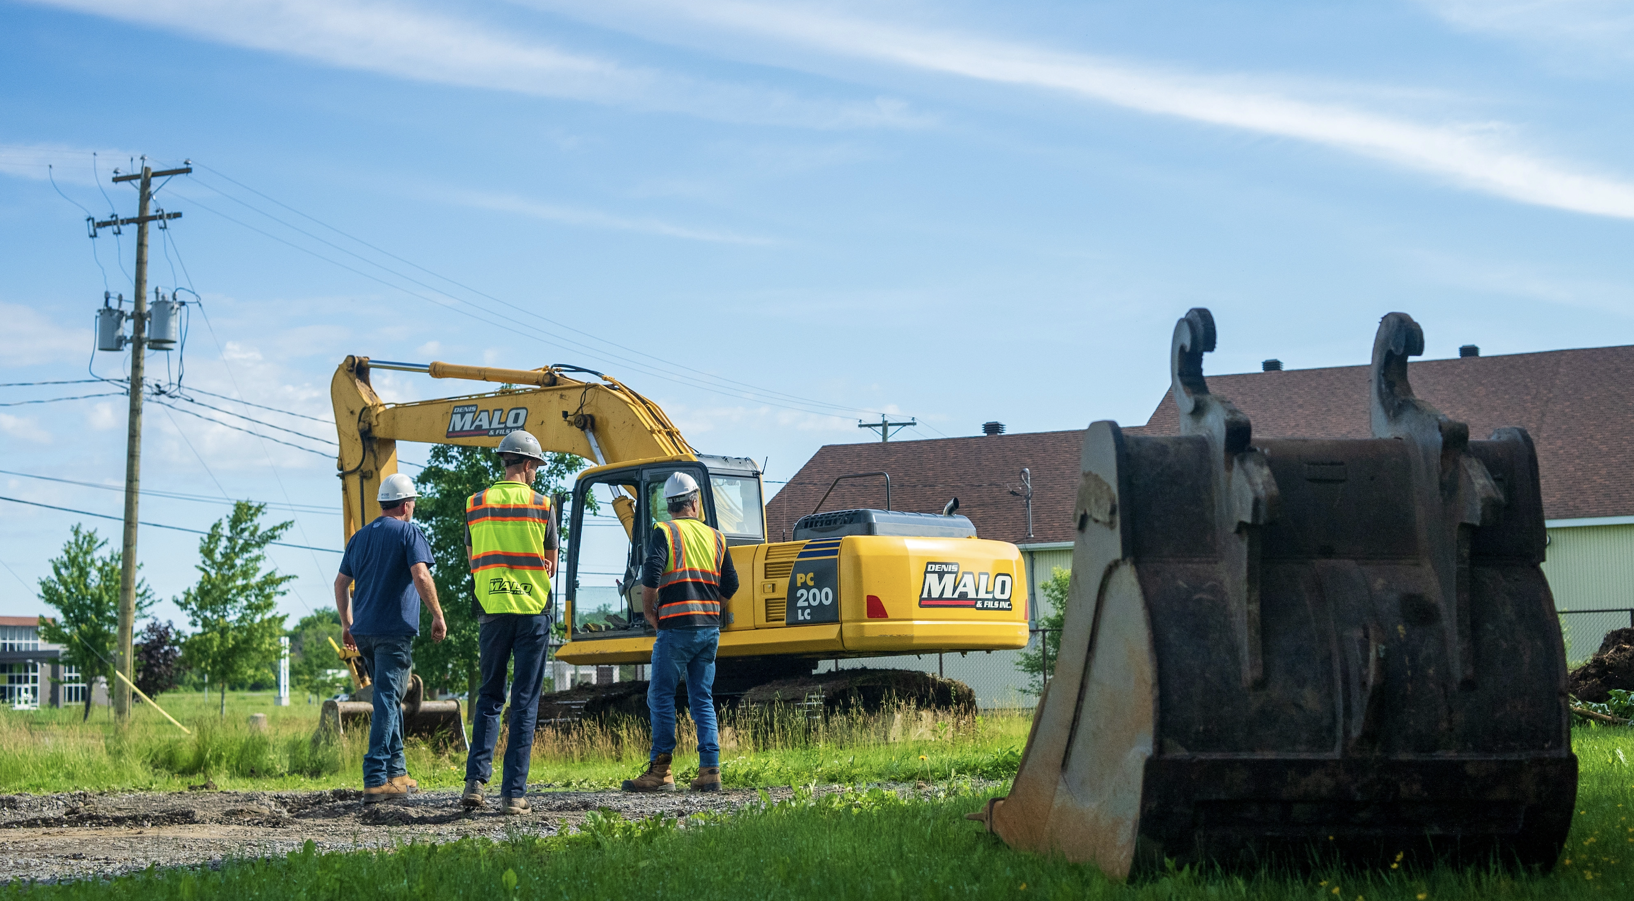
The construction crew stands on the future site of IMPACK's new machine assembly facility.

https://mktg.impack.ca/hubfs/2026%20Media%20Kits%20Press%20Releases/2026-06%20impack%20groundbreaking/2026-07-impack-new-building-groundbreaking-FXA06837.png

Featured Video:
https://youtu.be/Gs2zdsZIV1E


